**Site Reliability Engineering (SRE)**

* SRE is principles based on how Google runs production systems
  + Engineering approach to operations
* Basic problem statement 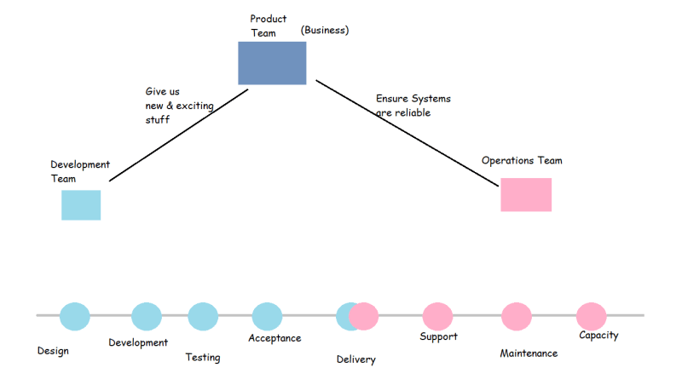
* Functions of Site Reliability Engineering
  + Reducing Toil
  + Managing Risk
  + Handling Failures
* For any application there are four golden signals
  + Latency: This is the time taken to send a request and recieve a response
  + Traffic: This is measured in number of requests flowing across the n/w
  + Errors: Errors can tell us about misconfigurations in infrastructure, bugs in application code or broken dependencies
  + Saturation: This defines th load on your network and server resources
* Service Level Indicator
  + Success Rate: for every 5000 requests send to the server 4800 requests are be successful
    - SLI : 96% of requests successful
  + Latency: For the last 5000 requests 4000 requests have latency less than 0.5 seconds, 600 with in 2 seconds and 300 within 5seconds
    - SLI : Latency of 80% request with in 0.5%, 92% with in 2s, 99.5 within 5 seconds
* Service Level Objective:
  + application will be up and available for 99.5% in a year